Data Activity 6
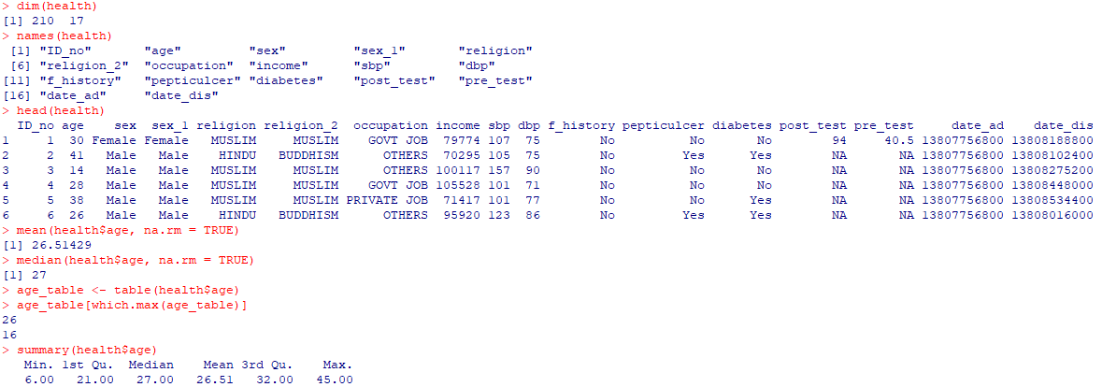
Question 1: Find out the mean, median and mode of ‘age’ variable.
The mean age of participants was 26.51 years, the median age was 27 years, and the mode was 26 years. This indicates that the average and middle values of the age distribution were very similar, with 26 years being the most frequently occurring age.

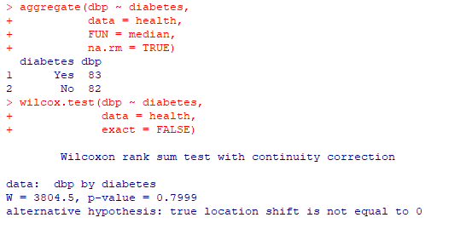
Question 2: Is median DBP the same among diabetic and non-diabetic participants?

The median diastolic blood pressure was 83 mmHg in diabetic participants and 82 mmHg in non-diabetic participants. A Wilcoxon rank-sum test found no statistically significant difference between the two groups (W = 3804.5, p = 0.7999). Therefore, the null hypothesis was not rejected, indicating that there was no evidence of a difference in DBP between diabetic and non-diabetic participants.

Question 3: Is systolic BP different across occupational groups?
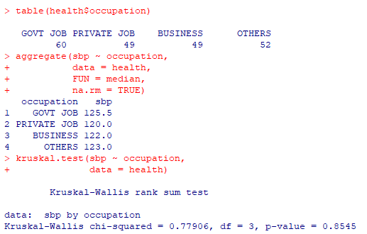
Median systolic blood pressure ranged from 120.0 mmHg in participants with private jobs to 125.5 mmHg in participants with government jobs. The Kruskal–Wallis test found no statistically significant difference in systolic blood pressure across the four occupational groups (χ²(3) = 0.779, p = 0.8545). Therefore, the null hypothesis was not rejected, suggesting that occupational group was not associated with a statistically significant difference in SBP in this dataset.

